package factorial;

import java.util.\*;

public class factorial{

    public static void main(String[] args) {

        //taking an input from the user

        System.out.println("Enter a number ");

        Scanner sc = new Scanner(System.in);

        //reading the number

        int number = sc.nextInt();

        //calling the factorial method and storing it in a variable

        int result = calculateFactorial(number);

        //printing the result

        System.out.println("Factorial of "+number+" is "+result);

        sc.close();

    }

    public static int calculateFactorial(int number){

        int result = 1;

        int iterator = number;

        if(number == 0 || number == 1){

            result = 1;

        }

        else{

        while(iterator > 0){

            result = result \* iterator;

            iterator --;

        }

        }

        return result;

    }

}

//Testing using Junit Testing

package lib;

import factorial.factorial;

import static org.junit.Assert.assertEquals;

import org.junit.Test;

public class test {

    @Test

    public void testFactorialOfZero() {

        assertEquals(1, factorial.calculateFactorial(0));

    }

    @Test

    public void testFactorialOfOne() {

        assertEquals(1, factorial.calculateFactorial(1));

    }

    @Test

    public void testFactorialOfSmallNumber() {

        assertEquals(6, factorial.calculateFactorial(3));

    }

}

Results:

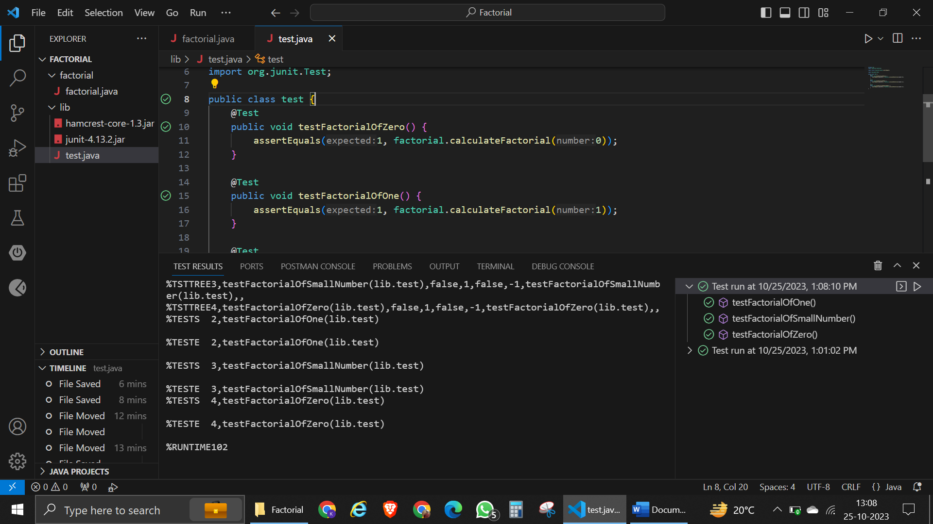

Result in terminal:

